Front elektrisk

Material på lager
Alla material möter direktivet 95/28/EC standards
Transparanta
Silvergrå |  | Charcoal
Ej transparant
Grå | Svart

Användningsområde: | Bussar, tåg marin och annat
Mekanism: | Elektrisk 24V
Information: | Den mörkare delen kan anpassas efter kundens önskemål och mått.  Det går även att lägga in en transparant del för bättre sikt.

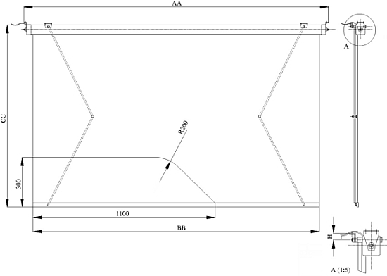
Copyright 2009 Veera Kaihdin Oy

